Committee on the Rights of Persons with Disabilities
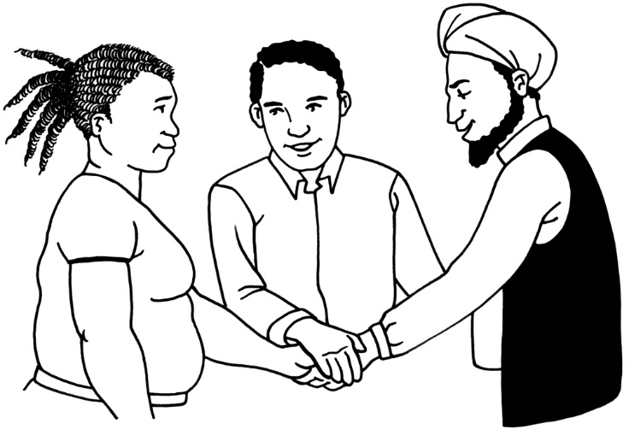

Easy Read

General Comment 7:
How to work together with Organisations of Persons with Disabilities

Note: This is not a United Nations official document.
What is in this document?

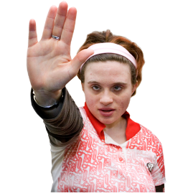
Page

Before you start 4


Hard words 5
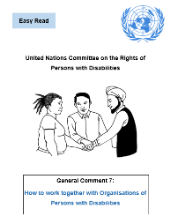

What is this document about? 6

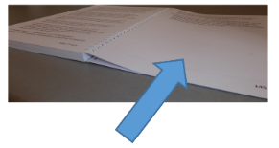
Article 4 point 3 11

Article 33 point 3 13

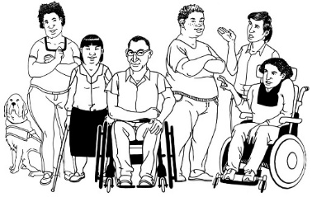
Page

What are Organisations of Persons with Disabilities? 15

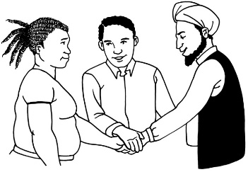
Why is it important for persons with disabilities to take part in this work? 28
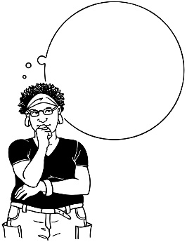

Why do we need a general comment on this? 31
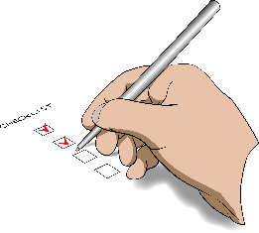

What should countries do? 33

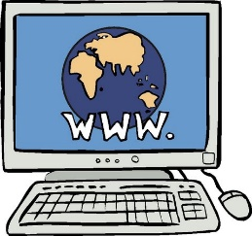
Page

How can I find out more? 43

List of hard words 45

Before you start
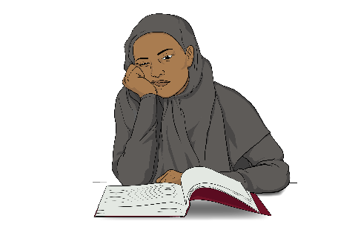

This is a long document.

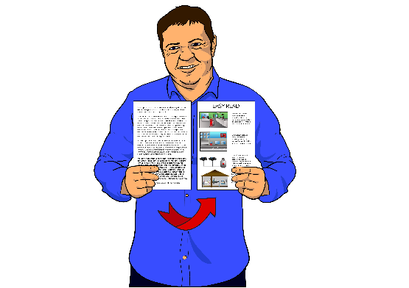
While it is written in Easy Read it can be hard for some people to read a document this long.

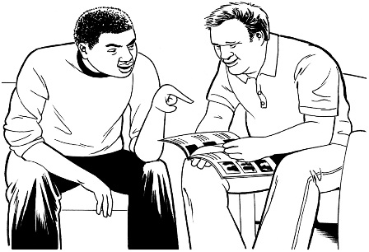
Some things you can do to make it easier are:
- read it a few pages at a time

- have someone help you to understand it.

Hard words
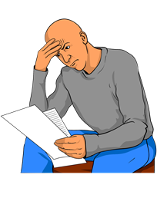

There are some words in this document that might be hard to read or understand.


Hard words in this document will be in large blue print.

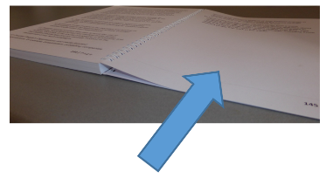
If you want to know what these words mean you can go to the List of hard words in this document on page 45.

What is this document about?

The United Nations
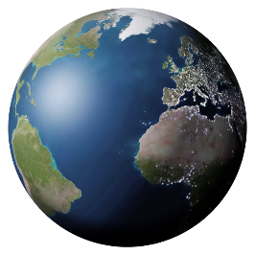
The United Nations is a place where all countries of the world come together.

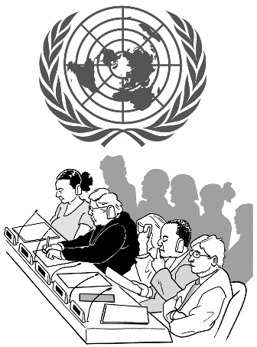
The United Nations is also called the UN.

The UN meets to:
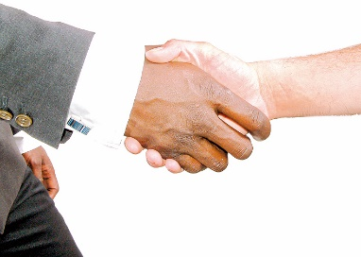
- talk about what is happening in the world

- try to agree how to make the world a better and safer place for everyone.

The Convention
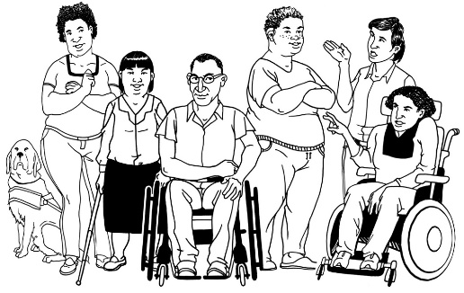
The UN has made an agreement called the Convention on the Rights of Persons with Disabilities.
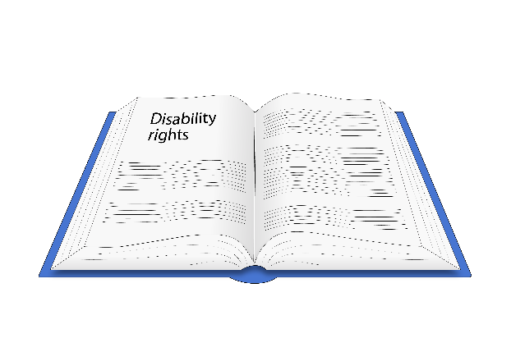

In this document we will call it the Convention.

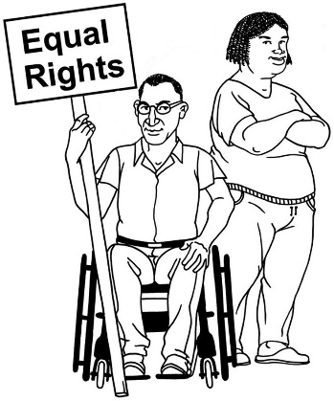
The Convention is about human rights for persons with disabilities.

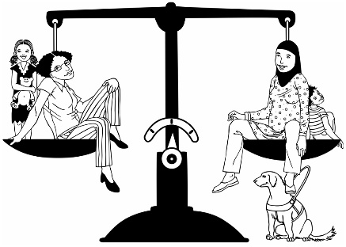
The Convention says persons with disabilities:
- have the same rights as persons who do not have disabilities

- should get their rights.
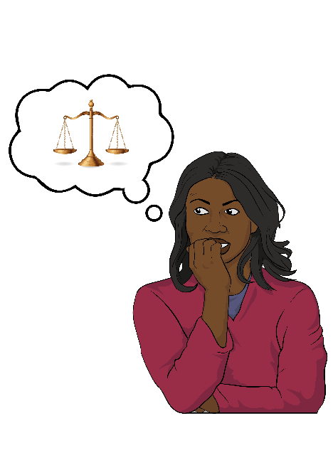
The Convention does not give persons with disabilities any new rights.

The Convention was made because sometimes persons with disabilities do not get their rights.

Nearly every country in the world has signed the Convention.

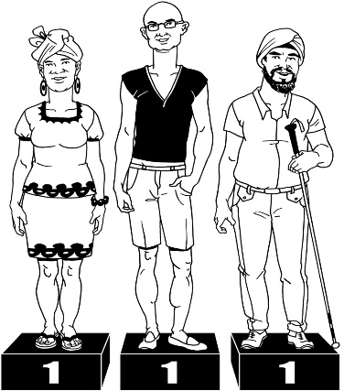
That means these countries have agreed to try and make sure persons with disabilities in their countries get their rights.

The Committee

There is a United Nations committee that looks after the Convention.

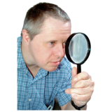
The Committee:
- checks that persons with disabilities all over the world get their rights
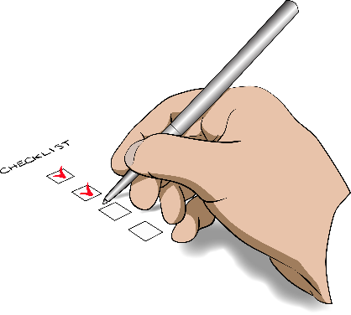
- helps countries understand what to do to make sure persons with disabilities get their rights.

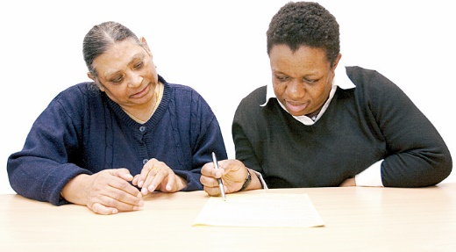
1 way the Committee helps countries understand what to do is by writing general comments.

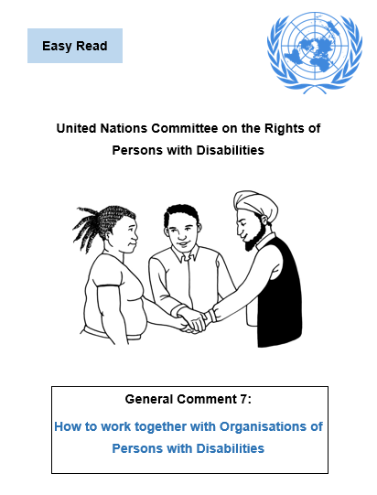
General comment 7

This document is about general comment 7 made by the Committee.

General comment 7 is about 2 parts of the Convention:
2
- article 4 point 3

- article 33 point 3.

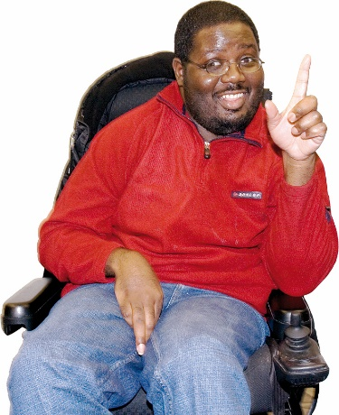
General comment 7 will help everyone to understand what these 2 parts of the Convention mean.

Article 4 point 3

Article 4 point 3 of the Convention is written like this:

Article 4.3
Article 4.3 of the Convention says countries should work together with Organisations of Persons with Disabilities.

In this document we will call these organisations OPDs.

To find out what an Organisation of Persons with Disabilities is go to page 15 of this document.
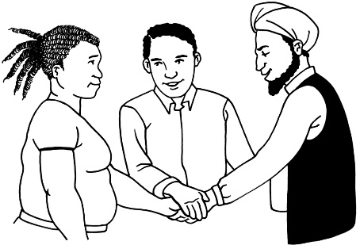
Countries should work together with OPDs when they do anything to make the rights in the Convention real for persons with disabilities.

Making the Convention real means making sure that persons with disabilities are getting the rights that are in the Convention.

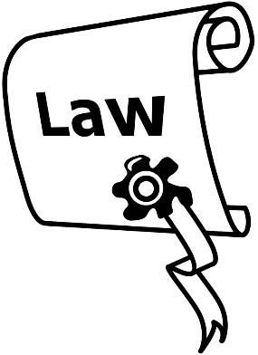
Article 4.3 says countries should work together with OPDs when they:
- make laws

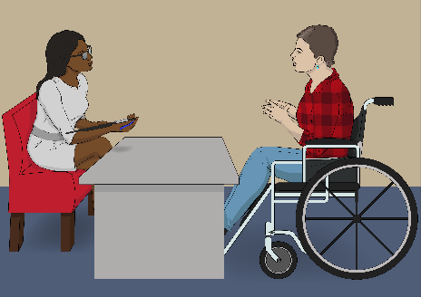
- use their laws

- make any decisions that affect persons with disabilities.

Article 33 point 3
Article 33 point 3 of the Convention is written like this:

Article 33.3
The Convention says it is important for countries to check:
- if persons with disabilities in their country are getting their rights or not
- how their country is going with making the Convention real.

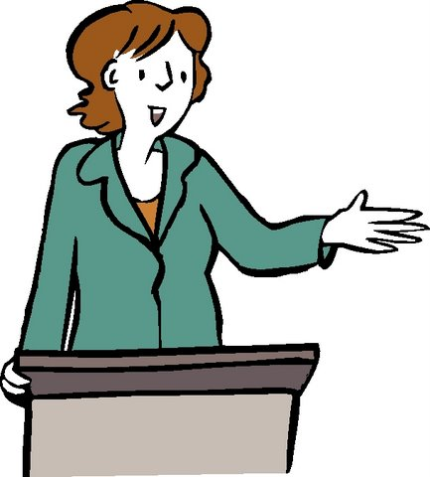
Article 33.3 of the Convention says this checking should be done by:
- governments

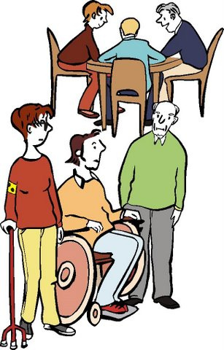
- people that are independent of the Government

- civil society organisations.
To find out what a civil society organisation is go to page 18 of this document.


Article 33.3 of the Convention says:
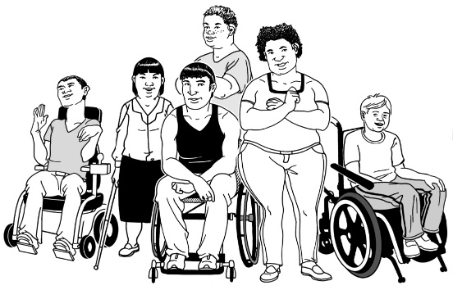
Organisations of Persons with Disabilities are the most important civil society organisations to take part in this checking.
What are Organisations of Persons with Disabilities?

The Convention says OPDs are organisations that should:
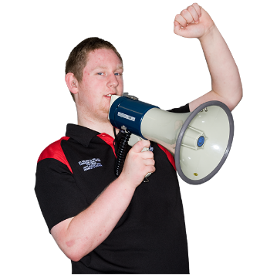
- be run by and for persons with disabilities

- have persons with disabilities as the ones who are speaking up

- follow the ideas of the Convention

- be working on making sure persons with disabilities get their rights

- be independent of political parties or groups.
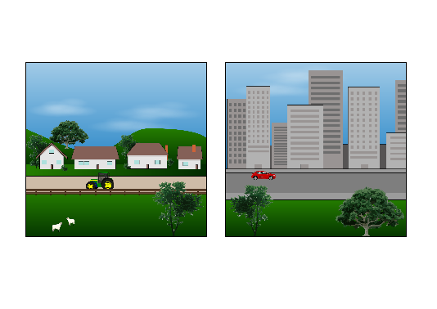
Some OPDs are:
- local – for a village or city

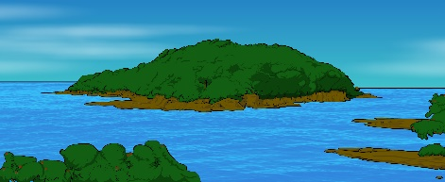
- regional – for part of a country

- national – for a whole country

- international – for more than 1 country.
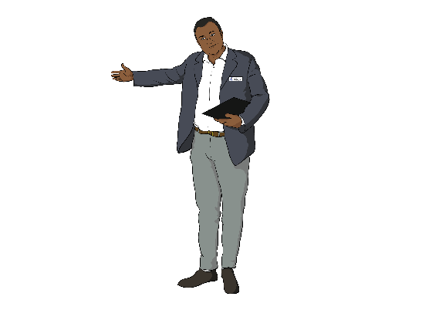

Some OPDs are formally registered organisations.
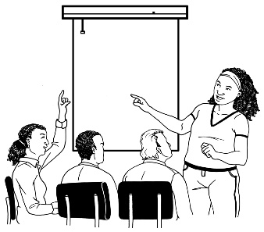

And some are not.

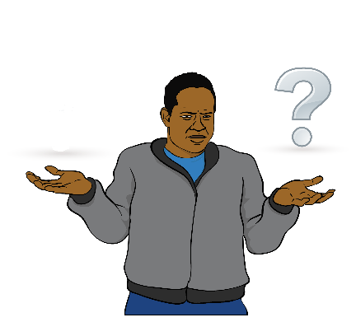
Sometimes people get confused about:
- which organisations are OPDs

and

- which organisations are not OPDs.

Civil Society Organisations

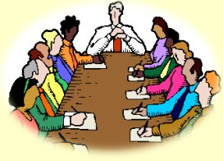
Civil Society Organisations are organisations that are not part of:
- governments

- business.

There are many different kinds of Civil Society Organisations.

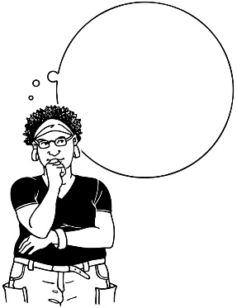
Sometimes people think all Civil Society Organisations are OPDs.

But some civil society organisations are not OPDs.
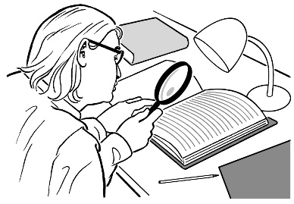
Some examples of Civil Society Organisations are:
- organisations that do research
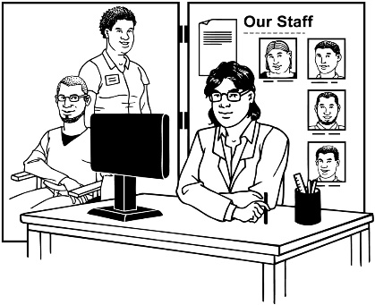
- organisations that give services

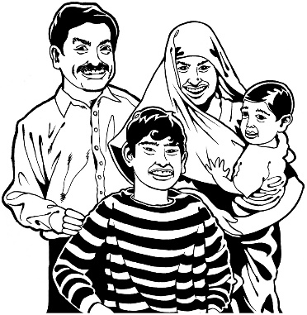
- organisations run by families of persons with disabilities

- Organisations of Persons with Disabilities.

OPDs are 1 kind of Civil Society Organisation.

Organisations for Persons with Disabilities

Organisations of Persons with Disabilities

are not the same as:

Organisations for Persons with Disabilities.

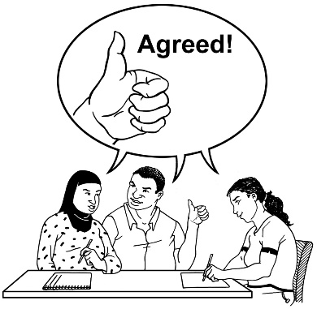
In an Organisation of Persons with Disabilities all of the people who run it will be persons with disabilities.

In an Organisation for Persons with Disabilities:
- some or all of the people who run it will be persons who do not have disabilities

- some of the people who run it may be persons with disabilities.

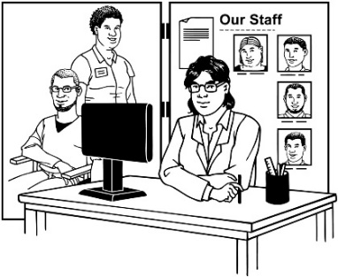
Organisations for Persons with Disabilities:
- can be disability services

- can be run by family members of persons with disabilities
- are mostly run by persons who do not have disabilities.

The Committee says there are 6 different kinds of Organisations of Persons with Disabilities:
6

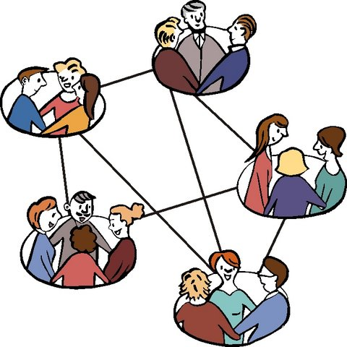
- Umbrella organisations

This is when different OPDs work together as a group.

- Cross-disability organisations

These are organisations run by and for persons with all different kinds of impairments.

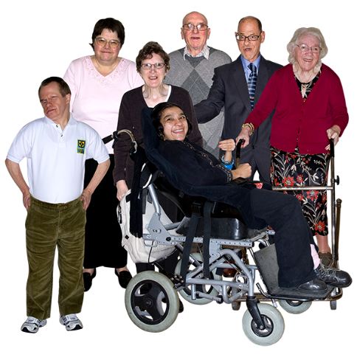
- Self advocacy organisations

These are OPDs that support persons to speak up for their rights.

These organisations are often run by persons with intellectual disabilities.

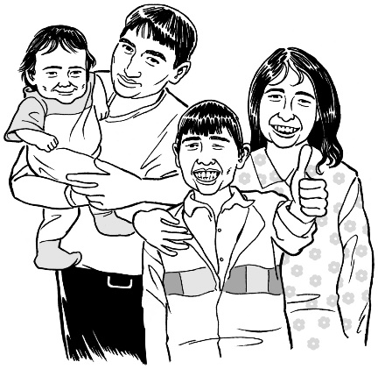
- Organisations that have family members of persons with disabilities in them

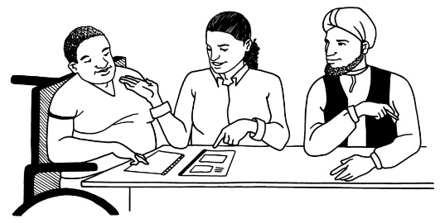
In these kinds of organisations family members should support the voices of the persons with disabilities in the group to be heard.

There is more about this on the next page.
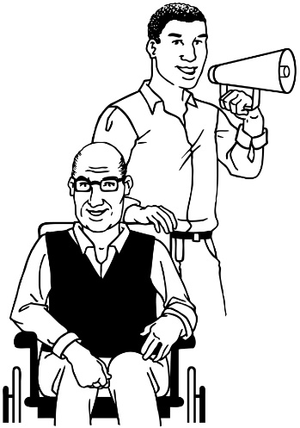
Organisations that have family members of Persons with Disabilities in them can be very important when:
- there are no OPDs for persons with disabilities

- they are speaking up for the rights of their family members with disabilities.

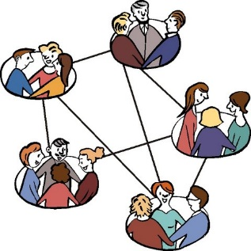

These kinds of organisations are not usually a good idea for most groups of persons with disabilities, like:
- adults with disabilities

- deaf persons

- blind persons

- persons with psychosocial disability.
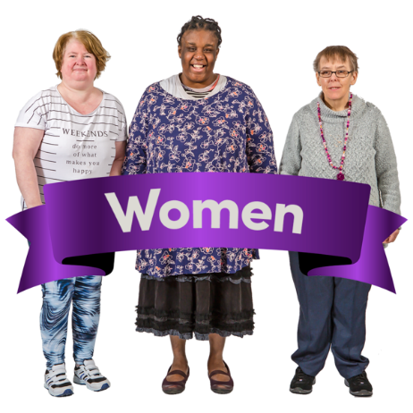
- Organisations of women and girls with disabilities

These organisations should be for women and girls with disabilities from all different backgrounds.

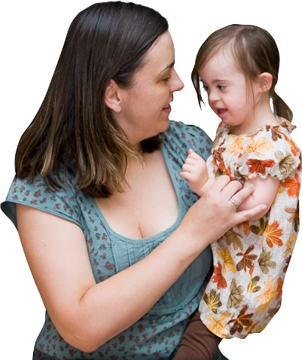
- Organisations of children and young persons with disabilities

In these organisations children and young persons with disabilities should be supported by adults to have a say about the things that affect them.

These organisations should support the voices of children.
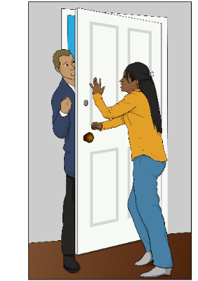
Who can be part of OPDs?

Sometimes OPDs do not let some persons with disabilities be part of their organisations.

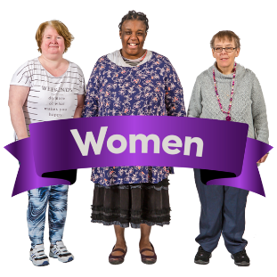
It is important to say that OPDs can be run by and for:
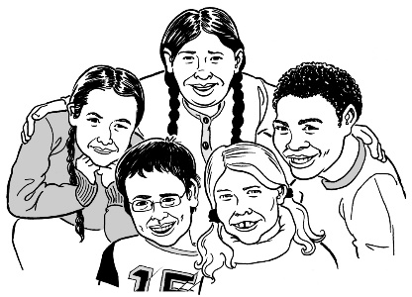
- women with disabilities

- children with disabilities

- people with 1 kind of impairment

- people with more than 1 kind of impairment
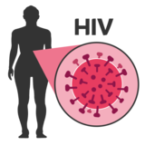

- persons with disabilities living with HIV or AIDS.
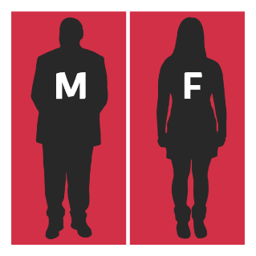
OPDs can also be run by and for persons with disabilities of different:
- genders
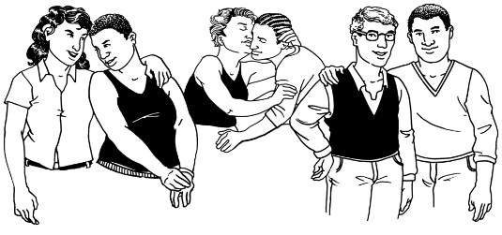
- sexual orientations
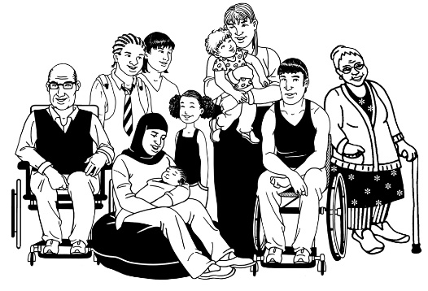

- cultures or skin colour

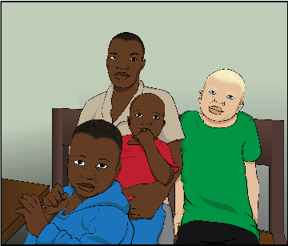
This also means people with albinism.

- ages
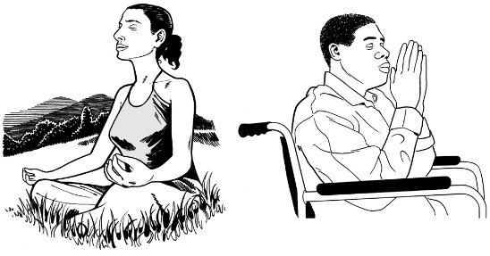

- religions
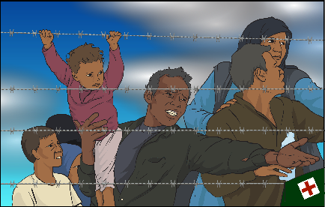
- migrant or refugee status.

Why is it important for persons with disabilities to take part in this work?
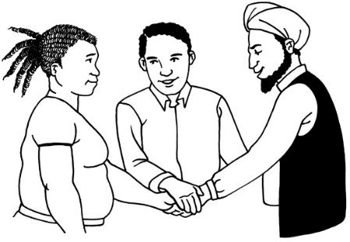
The Convention was made with the help of:
- persons with disabilities

- Organisations of Persons with Disabilities.

This way of working:

- made the Convention better

- showed the world that persons with disabilities can have a say
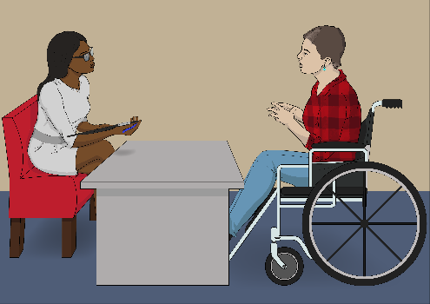
- is a human rights-based approach.
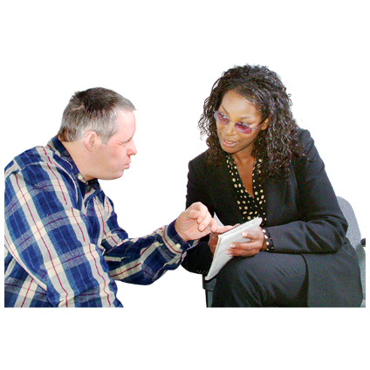
It is important for persons with disabilities to also take part in the work to make the rights in the Convention real.

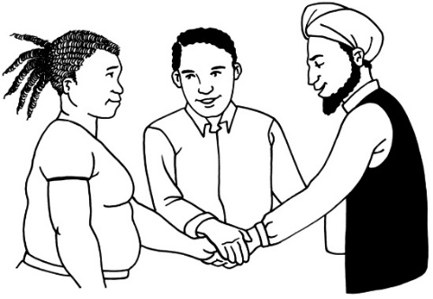
Countries should work together with Organisations of Persons with Disabilities to make this happen.


It is the best way.

If these organisations can take part in the work on the Convention:
- persons with disabilities will get better at speaking up
- countries will be able to hear from persons with disabilities about what needs to change.
If OPDs can take part in the work on the Convention it will also mean:
- countries are working in a way that follows the ideas of the Convention
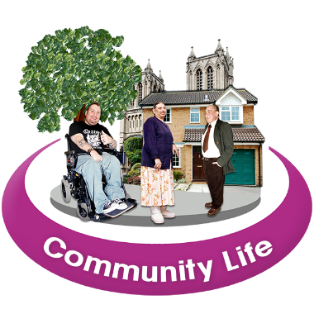
- more persons with disabilities will be part of everyday life in their communities

- governments of countries will have to work in a way that makes life better for the persons with disabilities who live there

- it will be easier for people to understand:

          - the choices made by governments

          - the ways that governments work to make rights real for persons with disabilities.
Why do we need a general comment on this?
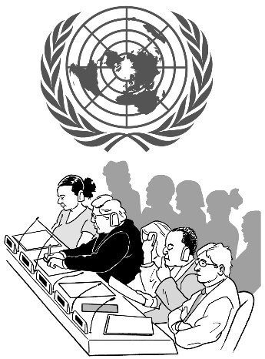
The Committee feels it is important that they make a general comment on:
- article 4.3

- article 33.3.

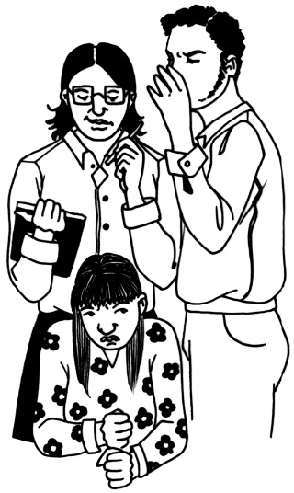
They feel this way as many persons with disabilities around the world are still being left out of:
- things that affect their lives

- planning

- decision making.

The Committee hopes that if they explain these articles more countries will understand what they should be doing.

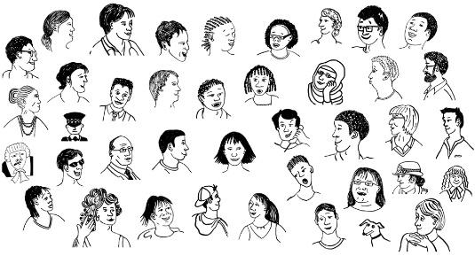
This will support countries to make the lives of persons with disabilities living in their countries better.

If countries talk to persons with disabilities when they are doing their planning they will do a better job of making the Convention real.

What should countries do?
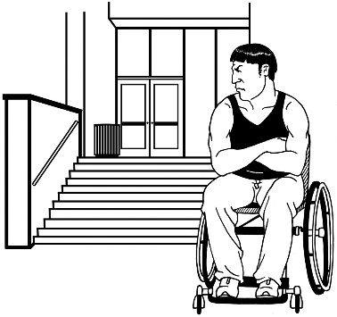
The Committee knows it may not always be easy for countries to work together with Organisations of Persons with Disabilities.
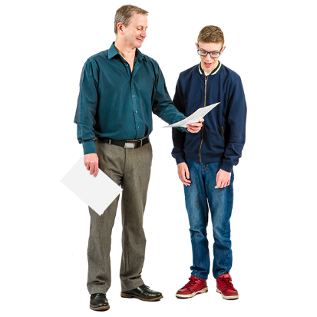

Countries should still try to do this even if it is sometimes hard.

Here is a list of the things countries should try to do to follow:
- article 4.3

- article 33.3.

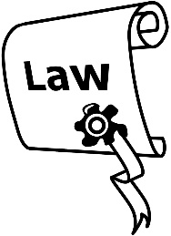
The Committee says countries should:
- take away any laws that stop people being part of OPDs

This also means taking away laws that say persons with disabilities are not able to make decisions.


- support OPDs by giving them:

  - funding
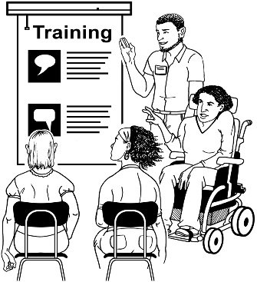
  - support

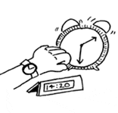
  - training on how to work well

  - time to work – this is because many OPDs are run by volunteers.
The Committee also says countries should:

- do what they can to help people start:
  - umbrella Organisations of Persons with Disabilities

See page 22 to see what umbrella organisations are.

  - cross-disability Organisations of Persons with Disabilities.

See page 22 to see what cross-disability organisations are.

It is important that all persons with disabilities can have a say in these organisations.

The Committee also says countries should:

- make it a rule that they need to work together with OPDs

- write down the best ways to work together with OPDs

- support OPDs to have persons with disabilities of different backgrounds in their organisations

- work with OPDs for women and girls when working on things that will affect them.

The Committee also says countries should:
- work with OPDs for children and young people when working on things that will affect them

- support OPDs that are working at all levels, like:

- local – for a village or city

- regional – for part of a country

- national – for a whole country

- international – for more than 1 country.

The Committee also says countries should:

- make sure OPDs are able to ask for and get funding from many different places

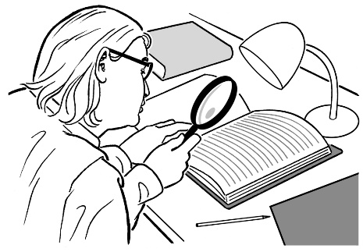
- support OPDs to be part of the checking to see if their countries are making the rights in the Convention real

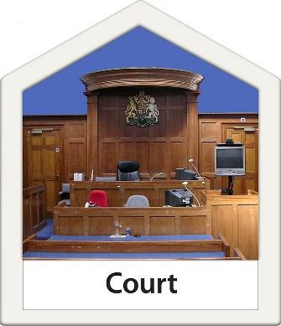
- work together with OPDs to think about how to make sure places in their country follow the ideas of the Convention.

This also means having rules about what will happen if places do not follow the ideas of the Convention.
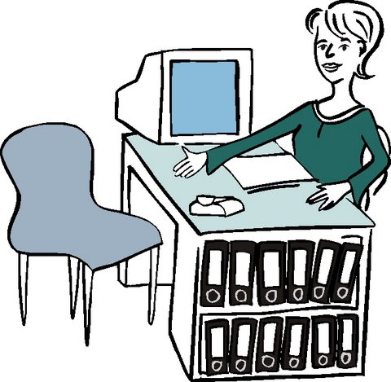
The Committee also says countries should:

- make it easy for OPDs to formally register
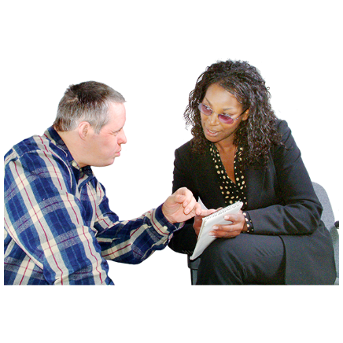

- make sure unregistered OPDs can take part in any work to make the Convention real

- make sure unregistered OPDs can take part in the checking to see if their countries are making the rights in the Convention real.

The Committee also says countries should:
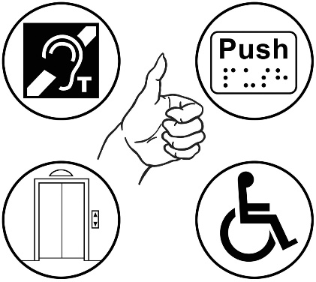
- make sure all of the work to make the Convention real is easy for persons with disabilities to access.
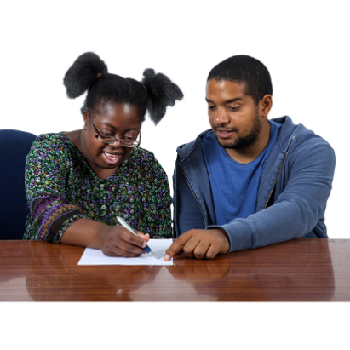
This means having things like:

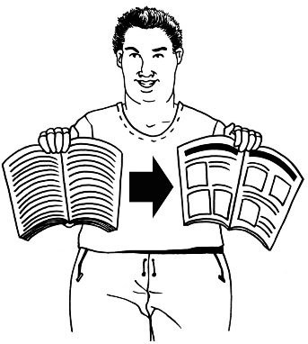
  - meeting assistants and support people

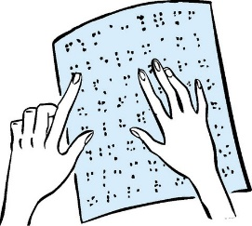
  - information in ways people can understand like:
    - Easy Read
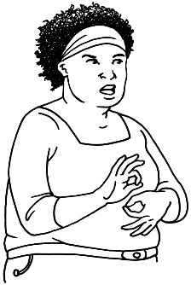
    - braille
    - sign language

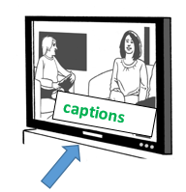
  - interpreters for Deaf and DeafBlind people

  - captions for information that is on TV.
The Committee also says countries should:
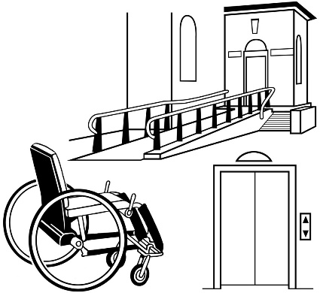
- make sure persons with disabilities can access all the government agencies and organisations that are working on the Convention

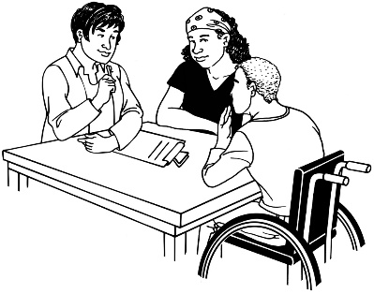
- make sure that OPDs can have a say in the work of National Human Rights Institutions
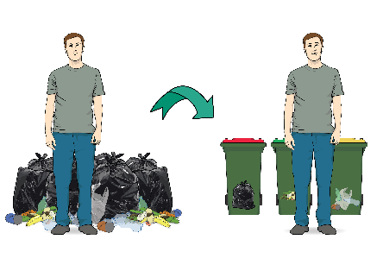

- work together with OPDs on other work too – even if it is not about disability.
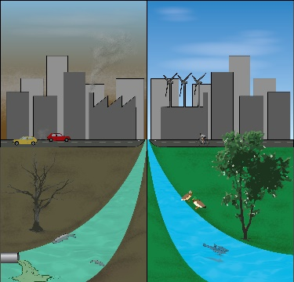
For example, they should work together on the Sustainable Development Goals.

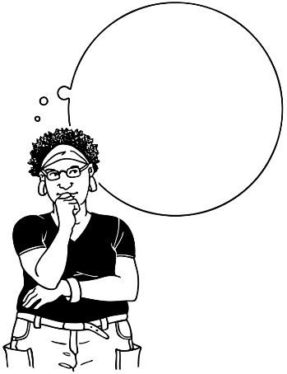
The Committee also says countries should:

- work together with OPDs to decide:

  - who will do the work to make the Convention real in their country
  - how governments and OPDs will know if their country is working well with OPDs

  - who will do the checking to see if their country is making the Convention real.

How can I find out more?
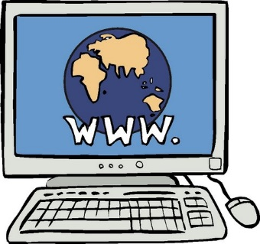

You can find out more about the Convention here:

https://www.un.org/development/desa/disabilities/convention-on-the-rights-of-persons-with-disabilities.html

This website has:
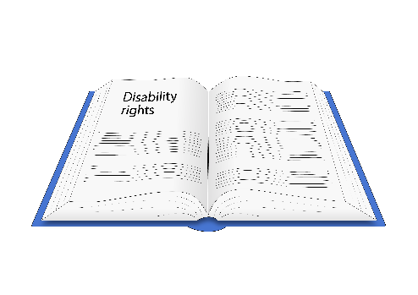
- original versions of the Convention – with hard words

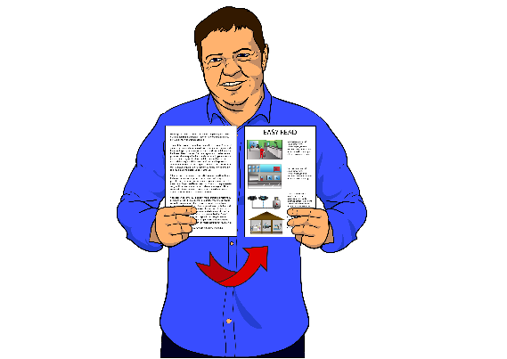
- Easy Read information about the Convention

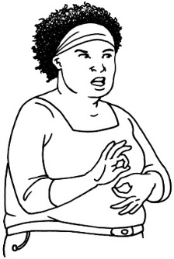
- sign language videos about the Convention

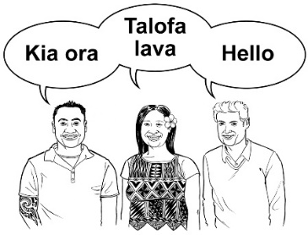
- the Convention in other languages.

You can find all of the general comments of the Committee here:

https://www.ohchr.org/EN/HRBodies/CRPD/Pages/Gc.aspx

Some of the general comments have been put into Easy Read.

You can find the Easy Read information about the general comments on the same website.
List of hard words

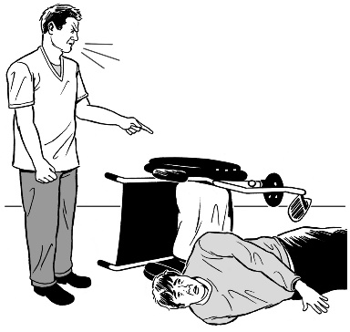
Abuse
Treating someone in a bad way.

There are many different kinds of abuse.
__________________________________________________
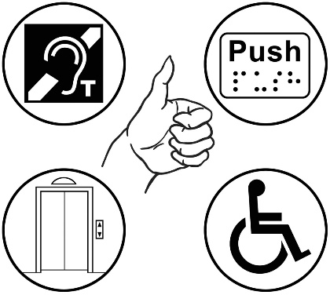
Access
Being able to use something, like:
- buildings

- transport.

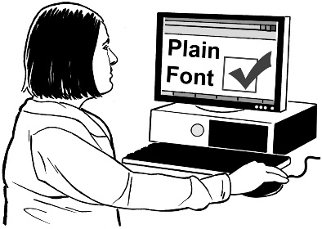
Access also means:
- being able to get the information you need

- getting information in a way you can understand.
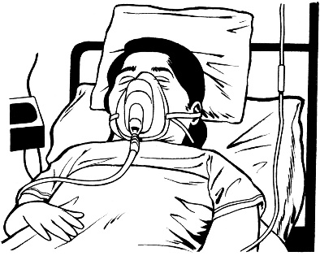
AIDS
This is a disease.

__________________________________________________
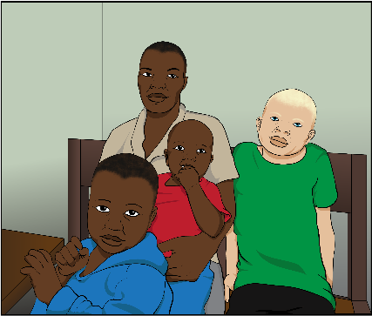
Albinism
This is a condition people can be born with.

It changes the colour of peoples’:
- hair

- eyes

- skin.
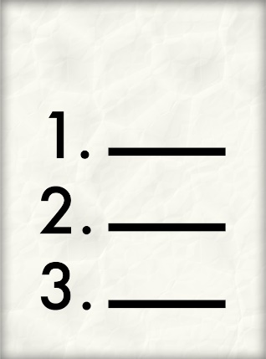
__________________________________________________
Article
United Nations conventions have lots of parts.

Many of the parts are called articles.

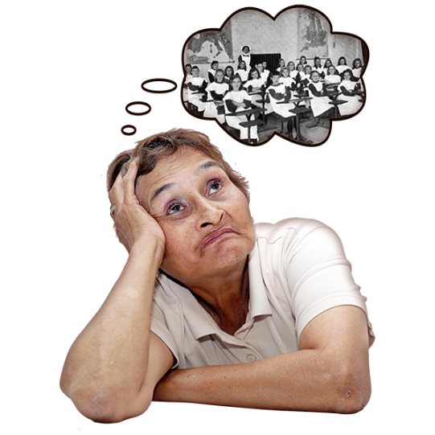
Backgrounds
Your background can mean:
- where you have come from

- what has happened in your life

- things about you, like your gender.

__________________________________________________
Business
Buying or selling things or services.

__________________________________________________
Captions
Words on a screen that show you what is being said in a film clip.

These can also be called subtitles.

Captions can assist deaf and hard of hearing people to do things like watch TV or go to the movies.
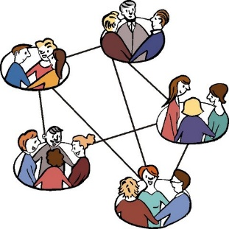
Civil society
Organisations and groups that are not part of the government or business.
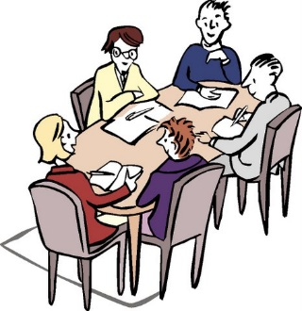
__________________________________________________
Committee
A group of people who work together on something.
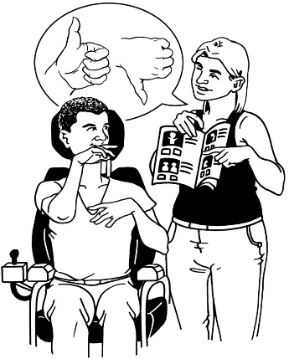
__________________________________________________
Communicate
Being able to share ideas with other people.

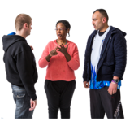
People communicate in different ways.

Some people:
- talk with their mouths
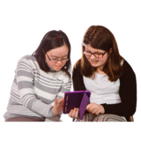
- use sign language

- use things like computers to talk to others.
Convention
A convention is an agreement about something.

The UN has many conventions.
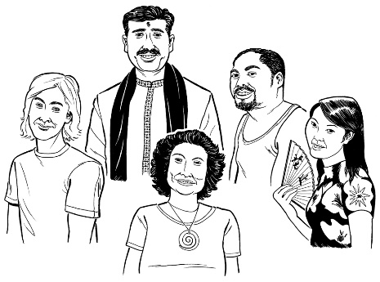
__________________________________________________
Culture
The way a group of people do things, like:
- celebrate special days

- the way they treat each other.
__________________________________________________
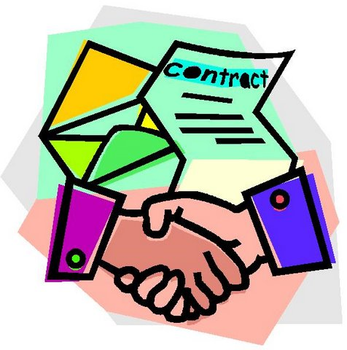
Formally registered
If an organisation has been formally registered this usually means their government has said yes to them being an organisation.

There is more about this on the next page.
In some countries governments only support OPDs that are formally registered.

In these countries formally registered organisations can find it easier to get:
- funding

- support.

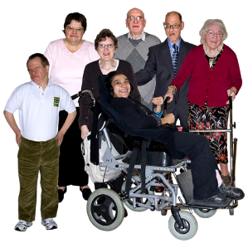

In some countries it can be very hard to register OPDs run by and for:
- people with intellectual disability

- people with psychosocial disability.
__________________________________________________
Funding
Money that is given to an organisation or person to do something.

Gender
How a person feels about whether they are:
- male
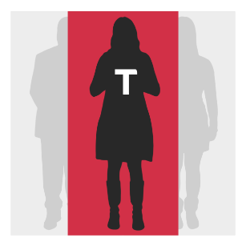
- female

- a mix of male and female

- not male or female.
__________________________________________________
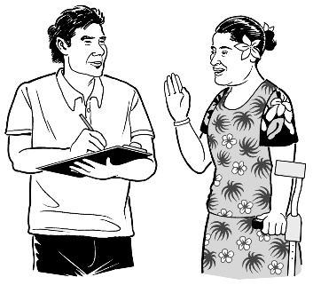
General comments
United Nations Committees make general comments to help explain the hard parts of conventions.

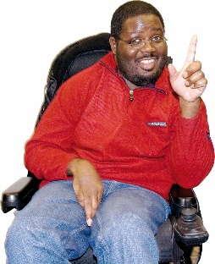
General comments:
- give people a better idea about what conventions mean

- help countries understand what to do to make conventions real.


Government
A group of people in charge of running a country.
__________________________________________________
HIV
HIV is a virus that can make you very sick.

If you do not treat the virus it can turn into the AIDS disease.
__________________________________________________
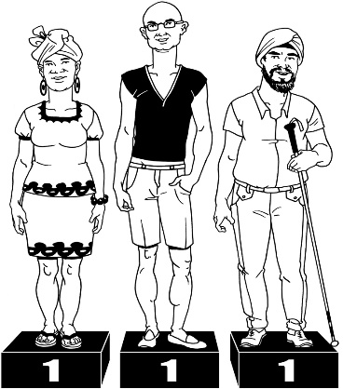
Human Rights
All people have Human Rights.

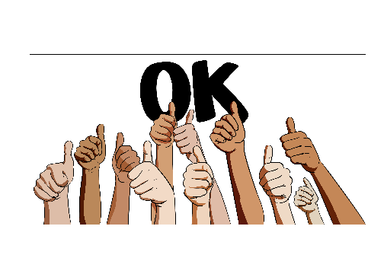
Governments need to make sure that people can get their rights all the time.

There is more about this on the next page.

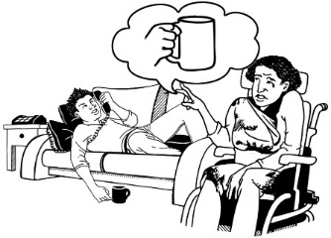
Human rights are things like:
- the right to food and water

- the right to housing

- the right to be safe from abuse.

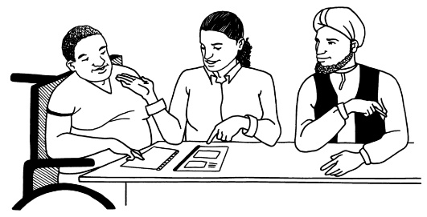
__________________________________________________
Human rights-based approach
This means a way of working that makes sure people get their rights.
__________________________________________________
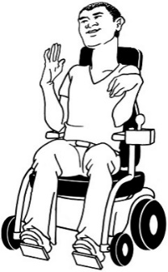
Impairment
This is about the way your:
- body works
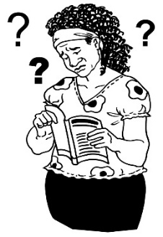
or
- brain thinks.

There is more about this on the next page.
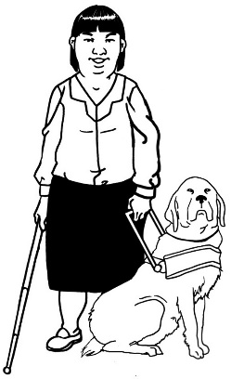
The word impairment is used when your body or brain have a hard time:
- doing some things

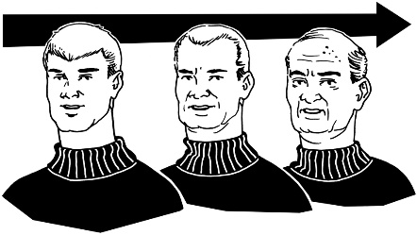
- and it will go on for a long time – like years or for your whole life.

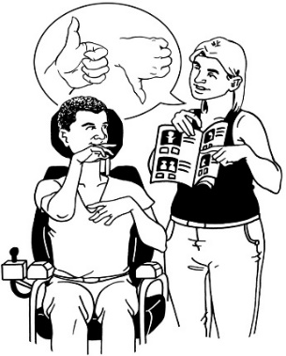
Some examples of impairments are things like not being able to:
- hear

- see

- talk.

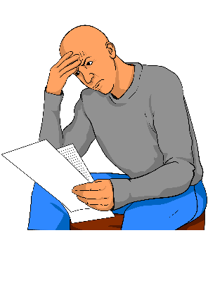
It can also mean having a harder time than other people with:
- understanding

- making choices

- learning new things.
Independent
In this book independent means:
- not working for the government

- not working for political parties.
__________________________________________________
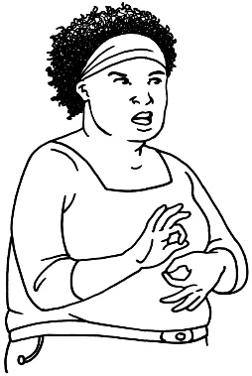
Interpreters
In this book interpreters are people who can communicate with people who are:
- Deaf

- DeafBlind.

Interpreters:
- use sign language

- assist people to communicate with other people.

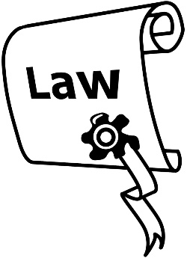
Laws
Laws are like rules for countries.

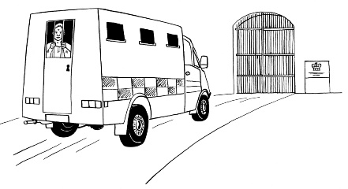
People may get in trouble if they do not follow the law of the country they are in.

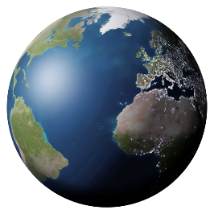
__________________________________________________
Migrant or refugee status
This is about people moving to live in a new country.
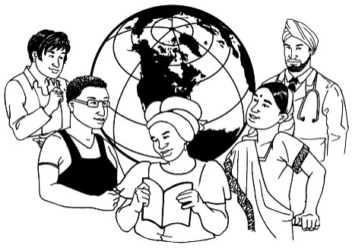
If a person gets to live in a new country they are called a migrant.
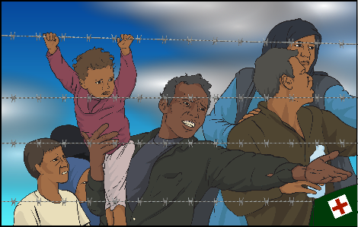
If a person needs to leave their country to be safe they are called a refugee.

There is more about this on the next page.
Migrant or refugee status means that a person is a:
- migrant
or a

- refugee.

__________________________________________________
National Human Rights Institutions
These are organisations that work on Human Rights for a country.

They tell the UN what is happening about human rights in their country.

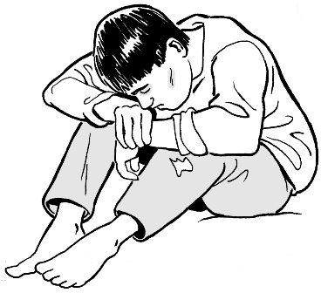
National Human Rights Institutions can talk to the United Nations Committee about what is going on for persons with disabilities in their country.
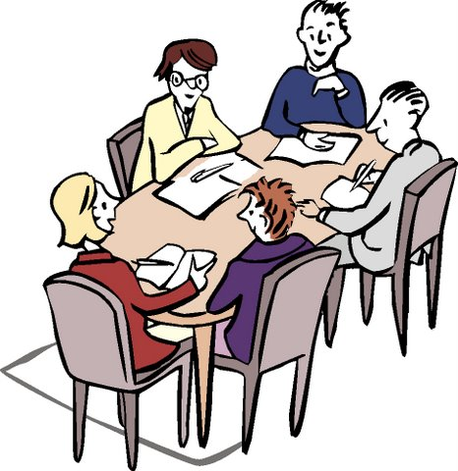
Organisations
These are groups of people that work on something together.

Organisations have rules about:
- how they work

- who can be in the group.
__________________________________________________
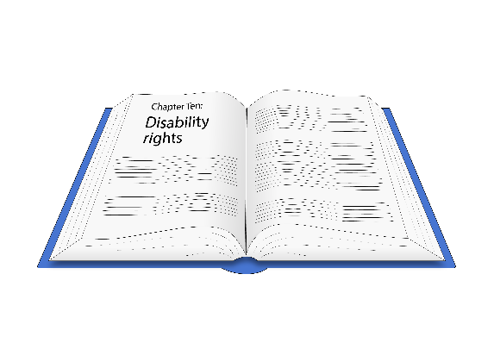
Original versions
In this book this means documents which are not in:
- Easy Read

- braille

- sign language.

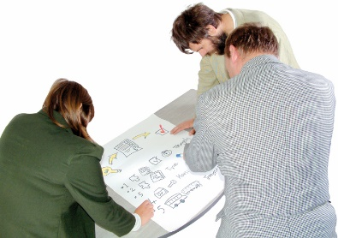
Planning
In this book this means when governments are thinking about:
- what work they need to do

- how they will do the work they need to do.
__________________________________________________

Political parties
These are groups who want to be part of the government of their country.

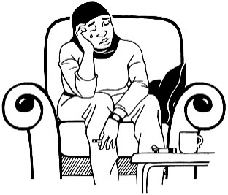
Psychosocial disability
This is a type of disability.

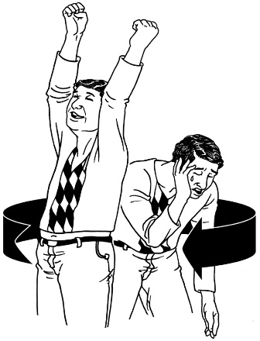
Here is a list of impairments that people with psychosocial disability may have:
- Depression
- Bi-Polar disorder
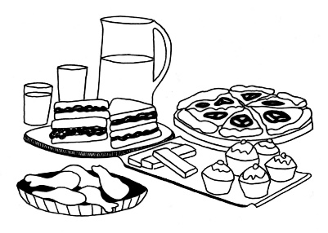
- Schizophrenia
- Post traumatic stress disorder
- Eating disorders.

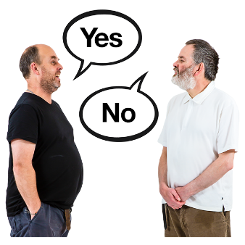
People with psychosocial disability may or may not have the impairments that are in this list.

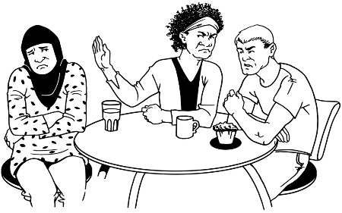
Psychosocial disability is about how a person’s life is affected by living with these kinds of impairments.
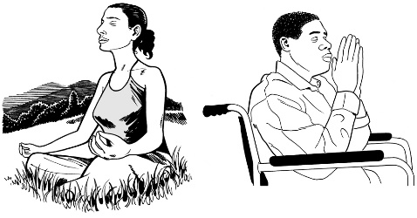
Religion
This is a belief in a God or Gods.

There are many different religions in the world.
__________________________________________________
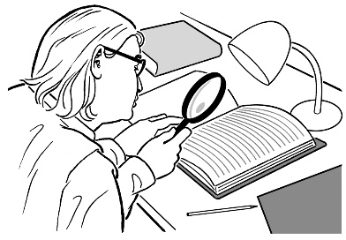
Research
This means:
- looking to find an answer to a question you have

- trying to find out how to do things better.
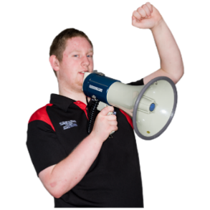
__________________________________________________
Self advocacy
Speaking up for your rights.

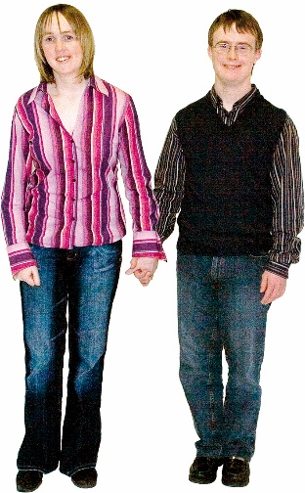
Sexual orientation
This is about who you would like to be with as a:
- sexual partner

- romantic partner.

Every person is different.

There are many different sexual orientations.

For example:
Some people want to be with someone who is the same gender as them.

Some people want to be with someone who is a different gender to them.
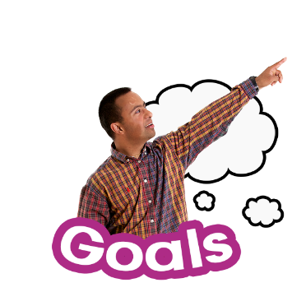
Sustainable Development Goals
The United Nations has made a list of 17 goals for the world.
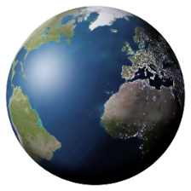
These are also sometimes called the SDGs.
You can find Easy Read information about the SDGs on this website:

https://iddcconsortium.net/sites/default/files/resources-tools/files/ida-iddc_agenda_2030_easy_read_1.0.pdf

__________________________________________________
Unregistered
If an OPD is unregistered this means the government of their country has not said yes to them being an organisation.

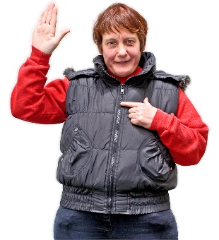
Volunteer
A person who chooses to do work for no pay.

Thank you to the following organisations for your support to make this Easy Read document available:
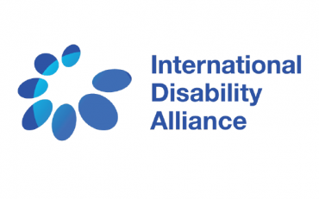
- International Disability Alliance
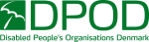
- Disabled People’s Organisations Denmark

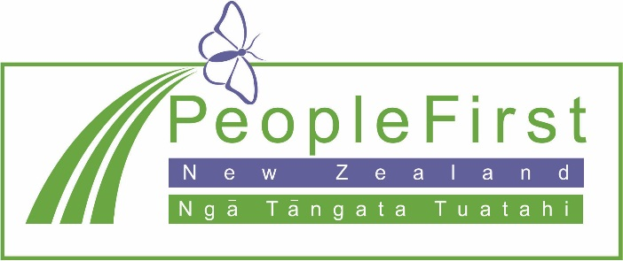

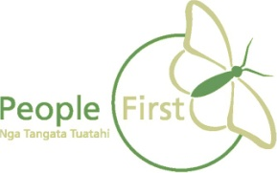
This information has been translated into Easy Read by People First New Zealand Inc. Ngā Tāngata Tuatahi


Images have been supplied by:

