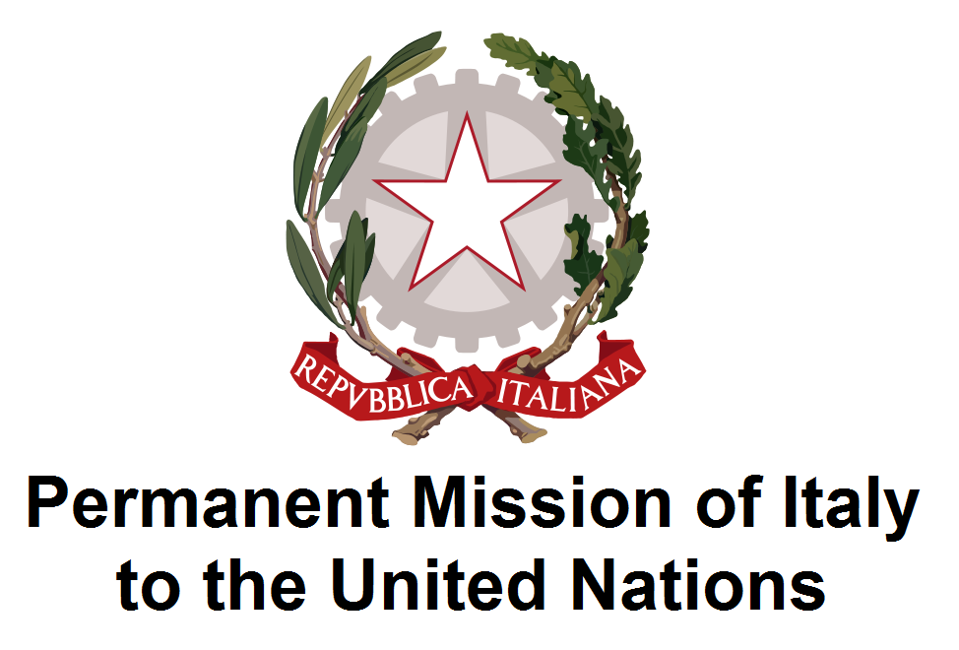
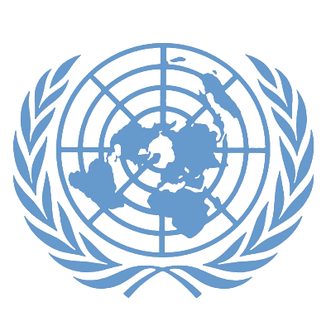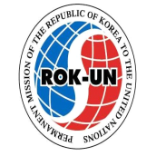
UNDESA REPUBLIC OF KOREA KENYA VANUATU BELGIUM ITALY

SAVE THE DATE

High Level Panel Discussion

Addressing disability issues and persons with disabilities
living conditions in critical situations.

Thursday, 11 June 2015, 1:10-2:50pm, Conference Room 4
United Nations Headquarters, New York

Welcoming Remarks 1.10 – 1.30pm

- Mr. Lenni Montiel, Assistant Secretary-General for DESA (TbC)
- Secretary of State Elke Sleurs, Belgium
- H.E. Sebastiano Cardi, Permanent Representative of Italy
- H.E. Oh Joon, Permanent Representative of Republic of Korea
- H.E. Macharia Kamau, Permanent Representative of Kenya
- H.E. Odo Tevi, Permanent Representative of Vanuatu

Panel discussion 1.30 – 2.45 pm

Moderator: Ms. Daniela Bas, Director, DSPD/DESA

- Mr. Hyung Shik Kim, Committee of the Rights of Persons with Disabilities, RoK
- Ms. Josephine Sinyo, Kenya
- Mr Giampiero Griffo, Italian Network Disability and Development (RIDS)
- Panelist from Vanuatu
- Panelist from Belgium
- Ms Akiko Ito, Chief, SCPRD, DSPD/DESA

Background
According to the 2011 World Report on Disability (WRD) more than 1 billion people - or approximately 15% of the world’s population - experience some form of disability, with 80% of these cases living in developing countries. The recently adopted Sendai Declaration and Framework for Disaster Risk Reduction (2015-2030), set out seven targets, four priorities and a set of guiding principles for a post 2015 framework for disaster risk reduction. In view of furthering disability inclusive development in the context of the post-2015 global development agenda, the panel will discuss the following issues:

Main objectives
- How accessible infrastructures can reduce the risks of injuries in disasters for persons with disabilities
- How assistive technology can provide support to persons with disabilities when designing disasters emergency plans and disaster programs for persons with disabilities
- Role of international cooperation to build adequate national capacity to design programmes for persons with disabilities in natural disasters.

For inquires related to this event, please contact: Mr. Salvatore Favazza (favazza@un.org), and/or Ms. Manou Zonderland (zonderland@un.org), DSPD/DESA

